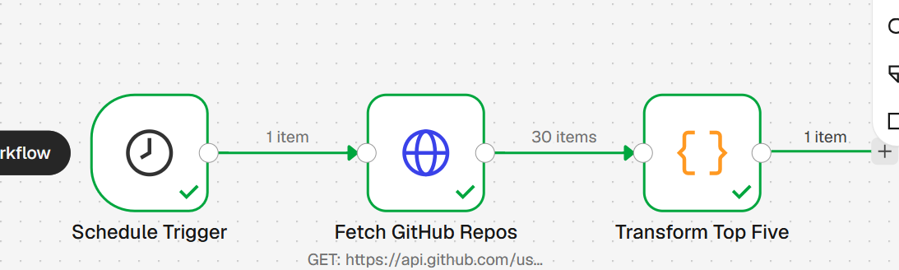

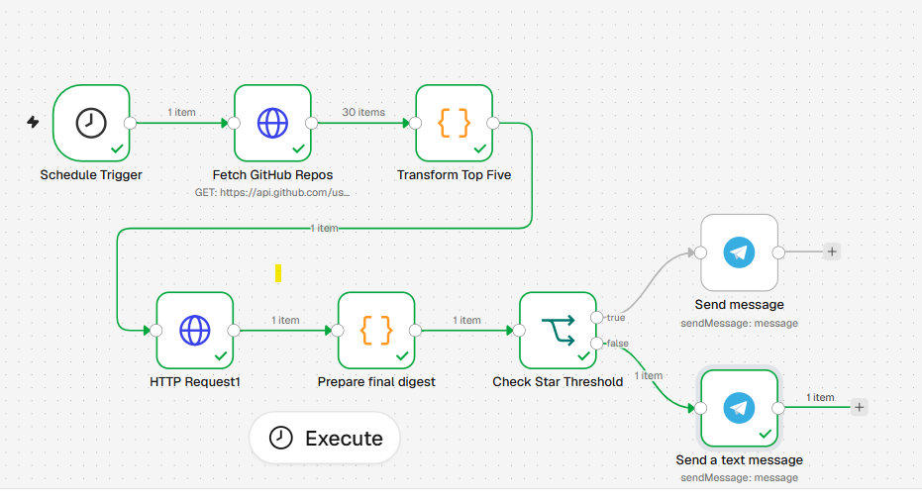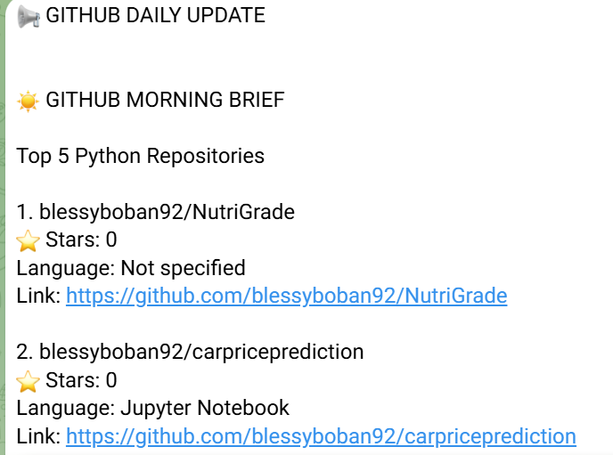Messages
GITHUB DAILY UPDATE GITHUB MORNING BRIEF Top 5 Python Repositories 1. blessyboban92/NutriGrade Stars: 0 Language: Not specified Link: https://github.com/blessyboban92/NutriGrade 2. blessyboban92/carpriceprediction Stars: 0 Language: Jupyter Notebook Link: https://github.com/blessyboban92/carpriceprediction 3. blessyboban92/nutriscore Stars: 0 Language: Python Link: https://github.com/blessyboban92/nutriscore 4. blessyboban92/assignmentclustering Stars: 0 Language: Jupyter Notebook Link: https://github.com/blessyboban92/assignmentclustering 5. blessyboban92/mysagit Stars: 0 Language: Not specified Link: https://github.com/blessyboban92/mysagit FEATURED REPOSITORY blessyboban92/NutriGrade Stars: 0 README: https://github.com/blessyboban92/NutriGrade/blob/main/README.md Generated by n8n Automation This message was sent automatically with n8n



